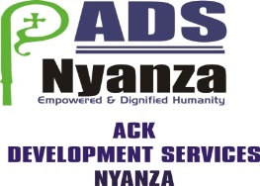

**ADVERTISEMENT**

**CALL FOR EXPRESSION OF INTEREST**

**DEVELOPMENT OF ADVOCACY STRATEGY**

ACK Development Services Nyanza Region is a non-profit-making faith-based organization serving vulnerable communities within the Six ACK Dioceses in Nyanza Region (Maseno South, Maseno West, Southern Nyanza, Bondo, Maseno East and Upper Southern Nyanza). The organization works to improve the livelihoods of the vulnerable communities in the six counties of Nyanza region – Siaya, Kisumu, Homabay, Nyamira, Kisii, and Migori.

The organization envisions *A dignified responsible humanity enjoying the fullness of life* and exist *to enable the Dioceses and communities of Nyanza region to achieve fullness of life and the integrity of creation through sustainable community development programs for the glory of God.*

The organization has three strategic goals, including improved livelihoods of target communities in the region through participatory and sustainable development approaches, improved church partnership and strengthened organizational capacity of ADS-Nyanza.

ADS-Nyanza seeks to develop an Advocacy Strategy to strengthen the capacity of ADS-Nyanza to influence decision-makers and stakeholders in prioritizing community needs and therefore calls for expressions of interest from qualified consultants to carry out the exercise.

Interested consultants should access TOR for documentation of the projects from the **tenders** under **‘what you can do’** menu of ADS-Nyanza Website [www.ads-nyanza.org](http://www.ads-nyanza.org)

The deadline for submission of expressions of interest is April 07th , 2025.